**Hack Challenge 2021  
  
FASHION REDEFINED WITH VIRTUAL GROOMING & SHOPPING ASSISTANT**

Submitted by

**Macharla Sai Lakshmi**

**FASHION REDEFINED WITH VIRTUAL GROOMING & SHOPPING ASSISTANT**

**INTRODUCTION**

**Overview**

The project mainly focuses on giving fashion recommendations based on analyzing the user’s look and their needs.

In this Project, the application will request a picture from the user, analyze their look and ask several questions about what they want. give further details here are the main steps that the application must do when interacting with the user:

* 1. The chat bot will ask for a picture of the user.
* 2. Using IBM Watson Visual Recognition, the application will detail the user’s physical look.
* 3. The chat bot will ask more questions about the user’s looks (for example the height if undefined by the picture) or the user’s need (for example if the outfit is for a formal meeting or just a relaxing event).
* 4. Based on the answer and the image analysis the chat bot will give the user fashion recommendations that will hopefully satisfy the user and meet their needs.

**Purpose**

This virtual assistant is a solution to create a social impact where fashion is within the reach of every individual and our vision is to spread fashion everywhere.

From local sellers to ecommerce websites, collections are brought into consideration while recommending it to the customers, which is a huge benefit for local dealers to improve their business.

**THEORITICAL ANALYSIS**

**Block diagram**

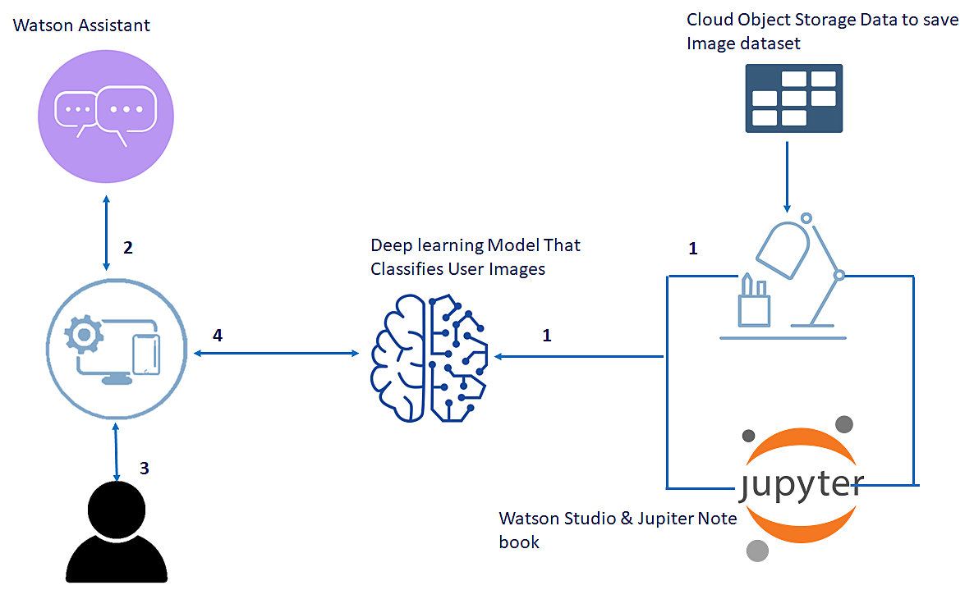

**EXPERIMENTAL INVESTIGATIONS**

Development of chatbots based on ontologies is seen as one of the promising practices in the world, where queries are answered by matching keywords in queries and retrieving appropriate responses placed on semantic representations. Whereas, IR based chatbots have an edge of producing informative and fluent responses, in a multi-turn conversation context, by seeking the responses from pre-generated conversation repository. In the proposed system, we employed a novel incremental approach for domain-oriented ontology engineering. In this regard, a wide range of development tools have been utilized; such as we use Proteg´ e for ontology engineering of the ´ domain of “clothing brands”. Proteg´ e is considered as one of ´ the best tools for ontology engineering in the entire world, which also enables us to export ontologies in various other language formats like Resource Description Framework (RDF) schema, and Web Ontology Language (OWL). Similarly, we used VOWL and OntoGraf plugins for the visualization of taxonomy, and SPARQL for querying system and data retrieval. Besides it, we as lo worked on Jena which is a Java-based library for the development of SW applications

**FLOWCHART**

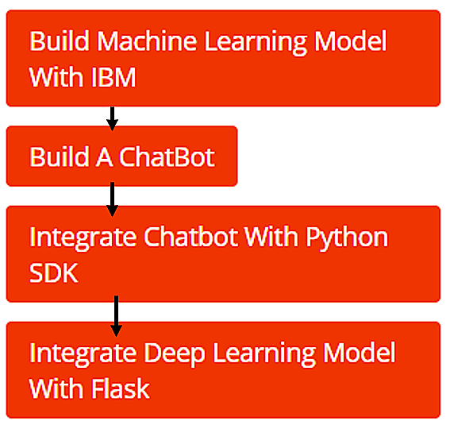

**ADVANTAGES & DISADVANTAGES**

**Advantages -**

* Easily study patterns from the interaction that the bot made with a user.
* Analyze and comprehend the context of the chat, to predict a user’s preferences and interests.
* know what style of outfit a user intends to purchase.
* Dig its database to find the right match depending on user preferences.
* Can continuously throw different questions to users and keep them engaged to gain access to user details about their choices.
* Implement image analysis to recommend the perfect outfit according to the user’s physique and style preferences.
* Implement Virtual search to display the desired apparels

**Disadvantages -**

Our work is limited to only ten clothing and provides concern areas information to customers; thus, in the future, the scope of brand ontology can be increased by adding more national brands.

**APPLICATIONS**

This virtual assistant is a solution to create a social impact where fashion is within the reach of every individual and our vision is to spread fashion everywhere.

From local sellers to ecommerce websites, collections are brought into consideration while recommending it to the customers, which is a huge benefit for local dealers to improve their business

**CONCLUSION**

In India, clothing brands lack instant AI assistants at their official websites and social web page., Several tussles are required to make a well-organized artificial bot to produce fast results. The proposed system resolves the problem for fashion industry through developing clothing brand ontology, yielded through the handcrafted dataset of 5000 pairs of questions/answers, and integrating it with a conversation agent to facilitate online customers. In our work, we focus only on general-purpose information like brand facilities, services, garments, clothing stuff, and accessories based on information retrieved from Facebook pages and official websites.